IPG Horizon NMS -Build Process

Version No.: 0.1

Date: 13-Aug-2018

Project Name: IPG

Project Code: C/181675

Copyright Notice

The contents of this document are proprietary to IPG Photonics and shall not be disclosed, disseminated, copied, or used except for purposes expressly authorized in writing by IPG Photonics.

Revision History

| Version No | Date | Prepared by / Modified by | Significant Changes |
| --- | --- | --- | --- |
| 0.1 | 13-Aug-2018 | HCL NMS Team | * Initial Version |
|  |  |  |  |
|  |  |  |  |
|  |  |  |  |

Table Of Contents

1. Introduction...................................................................................................... 3

1.1. Purpose...................................................................................................... 3

1.2 Scope................................................................................................ 3

1.3 Environment ................................................................................. 3

2 Build Process ........................................................................................... 3

3 Build Structure.................................................................................................. 4

4 ipgBuild.sh .................................................................................................... 5

5 Tools used..................................................................................... 5

5.1 Nightly build................................................................................................ 5

5.2 Interactive Build..................................................................................................... 5

Glossary

|  |  |
| --- | --- |
| Abbreviation | Description |
|  |  |
|  |  |
|  |  |
|  |  |
|  |  |
|  |  |
|  |  |
|  |  |
|  |  |
|  |  |
|  |  |
|  |  |
|  |  |
|  |  |
|  |  |
|  |  |

# IPG NMS Build

## Introduction

This section provides some preliminary information and an overview of the document.

1.1. Purpose

1.2. Scope

1.3. Environment

1.3.1 Repository

tool used :SVN

source folder structure

ipgNMS-project

commons

fault-mgmt

config-mgmt

account-mgmt

performance-mgmt

security-mgmt

client-src

Build process already mentioned as one of the main section

1.3.2 Deployment

JBOSS deployment enveronment

1.3.3 Build System design

<TBD>

## Purpose

This document describes the Build process of the Project

## Scope

This document defines the scope of Build for only the IPG Horizon NMS (NMS Server and NMS Web Client) modules

## Environment

1. The build Server installed with SVN client(command mode) ,buildscript run the cli commonds to get the latest code from svn like

*svn update*

1. In this environment non-graphical mode(CLI) of the svn will be used with the help of svn commands(*svn update,svn diff filenam*)
2. The code to be build will be copied from home/snapshot to the build location (home/ipgBuild/src) the generated war files(at home/ipgBuild/output) of the build will be moved to server JBOSS_HOME/standalone/deployments
3. All the operations

1)get latest code from svn

2)copy to the home/ipgBuild/src folder

3)run ipgBuild.sh

4)copy the wars from output folder to ***JBOSS_HOME/standalone/deployments*** are automated by the Linux script

1. There will be a Jenkins job to run the script to gegerate the NMS build as per predefined schedule

## Build Process

* It should get the latest source code from version controller and copy the code to *ipgBuild* folder and start the build script
* Once the Build successful the output of the build must be moved to *output(home/ipgBuild/output)* folder
* The NMS GUI Client Code code is built with the Angular JS command ng build and output directed to *output* *(home/ipgBuild/output)*folder on Build machine
* *JBOSS_HOME=home/ipgNMS_server/Jboss*
* The archetypes from the output folder are moved to the Server machine to this location ***JBOSS_HOME/standalone/deployments***

3

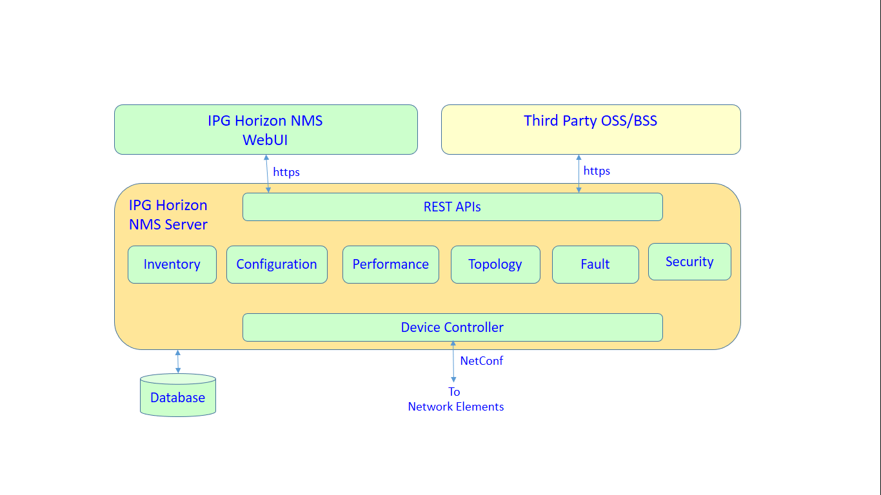1

Build Structure

The Main Project is responsible for build all sub projects(Modules) that includes the utils(jar)

IPGNMS Build is using Maven a third party and freeware tool

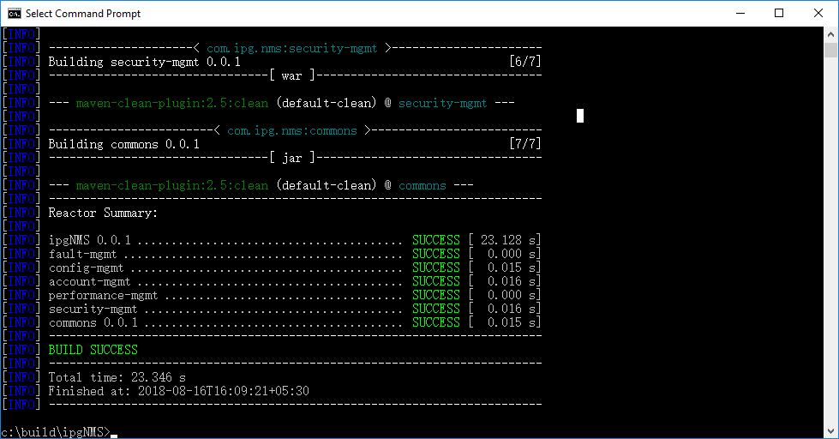

* home/ipgBuild {a folder on Build machine}
* ipgNMS-project

pom.xml (Parent pom)

* commons

pom.xml (Module pom)

* fault-mgmt

pom.xml (Module pom)

* config-mgmt

pom.xml (Module pom)

* account-mgmt

pom.xml (Module pom)

* performance-mgmt

pom.xml (Module pom)

* security-mgmt

pom.xml (Module pom)

* home/output {a folder on Build machine}
* server {contains all IPGNMS wars and jars}
* client {Contains IPGNMS client code}

Parent and module pom are linked by snippet

In each module pom: -

<parent>

<groupId>com.ipg.nms</groupId>

<artifactId>ipgNMS</artifactId>

<version>0.0.1</version>

</parent>

**4 ipgBuild.sh**

This Script is responsible for build NMS and NMS GUI Client Code code and deploy(copy) to the respectively

**5 Tools used**

The tools used are Maven, svn ,Angular CLI and Jenkins

|  |  |  |  |
| --- | --- | --- | --- |
| Sr No | Tool Name | Tool Version | License Type |
| 1 | Maven | 3.5.4 | Apache License, Version 2.0 (current) https://www.apache.org/licenses/LICENSE-2.0 |
| 2 | SVN | 1.10.1 | TortoiseSVN is under the GPL license |
| 3 | Jenkins | 2.121.3 | Creative Commons Attribution-ShareAlike 4.0 license |
| 4 | Angular CLI | 6.4.0 | https://github.com/angular/angular-cli/wiki |

This is automation process triggred by the Jenkins at configurable time

**5.2 Interactive Build**

This is a user initiating(trigger) job for testing the patch tr

|  |  |
| --- | --- |
|  |  |
|  |  |
|  |  |
|  |  |
|  |  |
|  |  |
|  |  |
|  |  |

|  |  |
| --- | --- |
|  |  |
|  |  |
|  |  |
|  |  |
|  |  |
|  |  |
|  |  |
|  |  |
|  |  |
|  |  |
|  |  |
|  |  |
|  |  |
|  |  |
|  |  |
|  |  |

|  |  |
| --- | --- |
|  |  |
|  |  |
|  |  |
|  |  |
|  |  |

|  |  |
| --- | --- |
|  |  |
|  |  |
|  |  |
|  |  |
|  |  |
|  |  |
|  |  |
|  |  |
|  |  |
|  |  |

|  |  |
| --- | --- |
|  |  |
|  |  |
|  |  |
|  |  |
|  |  |
|  |  |
|  |  |
|  |  |
|  |  |

|  |  |
| --- | --- |
|  |  |
|  |  |
|  |  |

|  |  |  |
| --- | --- | --- |
| Reference | File | Version |
| IPG Horizon SOW | IPGPHOTONICS_117431_SOW1_1May2018_EGolovchenko-signed | 2.2 |
|  |  |  |
|  |  |  |